SMART PARKING

Group Members

ARUN.D

ARUN.B

DIWAKARAN.A

MANIKANDAN.E

SANTHOSH.M

PROBLEM:

A popular shopping mall(Bharat) has parking place in first floor.

maximum 200 vehicles can park there.

Is there parking space? isn't it? and how easy it can make parking?

By using IoT(Internet Of Things).

**Definition**

The project involves integrating IoT sensors into public transportation vehicles to monitor ridership, track locations, and predict arrival times. The goal is to provide real-time transit information to the public through a public platform, enhancing the efficiency and quality of public transportation services. This project includes defining objectives, designing the IoT sensor system, developing the real-time transit information platform, and integrating them using IoT technology and Python.

**OBJECTIVES:**

**1.Real-time Parking Space Monitoring:**

Develop a system that monitors parking spaces in real-time using IoT sensors to detect occupancy and vacancy accurately.

**2.Mobile App Integration:**

Create a user-friendly mobile application that allows drivers to access real-time parking availability information, make reservations, and navigate to available parking spots conveniently.

**3.Efficient Parking Guidance:**

Implement a smart parking guidance system that directs drivers to available parking spaces through clear

signage, mobile app notifications, and guidance within the parking facility.

IOT SENSOR DESIGNS:

**1.Sensor Requirements:**

* Determine the specific requirements for your IoT sensors, including the type of sensor ( ultrasonic, infrared, magnetic) and the level of accuracy needed.

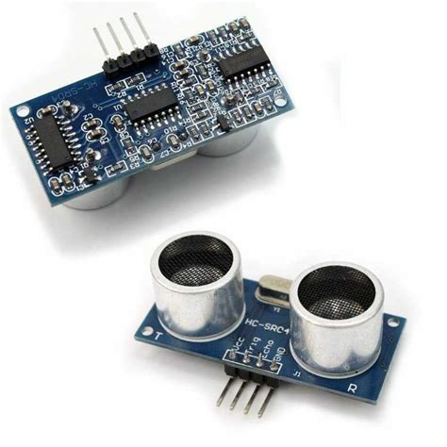

Fig : Ultrasonic sensor

**2. Sensor Placement:**

Identify optimal locations for sensor placement within parking spaces. Consider factors such as visibility, protection from weather, and accessibility for maintenance

**3. Power Source:**

* Decide on the power source for the sensors. Options include battery-powered sensors, solar-powered sensors, or wired sensors with a reliable power supply.

**4. Sensor Calibration:**

* Calibrate the sensors to accurately detect the presence or absence of vehicles in parking spaces. Test the sensors to ensure they provide reliable data.

**5. Data Transmission:**

* Establish a data transmission mechanism from the sensors to a central control system or a cloud-based platform. Ensure that data is transmitted securely and in real-time.

**6. Connectivity:**

* Choose the communication technology for the sensors. Common options include Wi-Fi, LoRa WAN, or cellular connectivity.
* Using shopping mall cellular connectivity

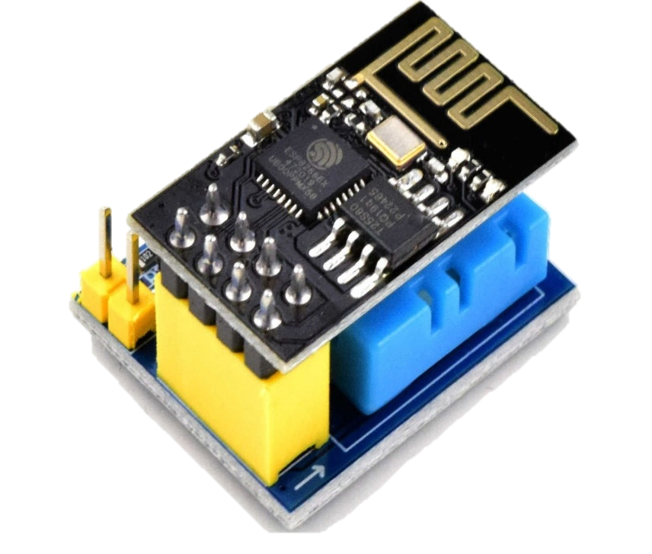

Fig: WiFi-module

Real-Time Transit Information Platform:

**Wireframing and Prototyping:**

* Begin with wireframing and prototyping to create a basic layout and structure of the app. Use tools like tinkercat,wokewi

**Map Integration:**

* Integrate a map feature to display parking locations and availability. Use a mapping service like Google Maps or Mapbox to provide accurate and up-to-date information.

**Notifications and Alerts:**

Implement push notifications and alerts to inform users about available parking spots, reservation confirmations, and reminders.

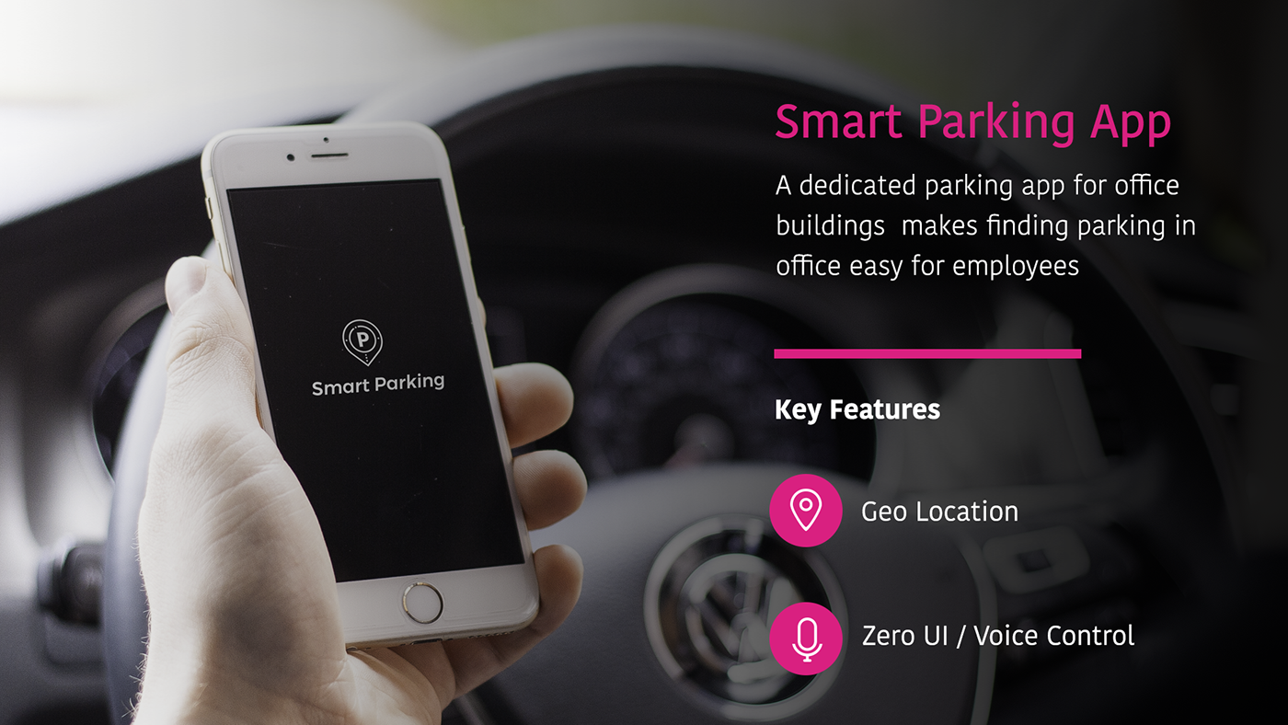

Fig: A dedicated parking app for shopping mall makes finding parking and easy for customers

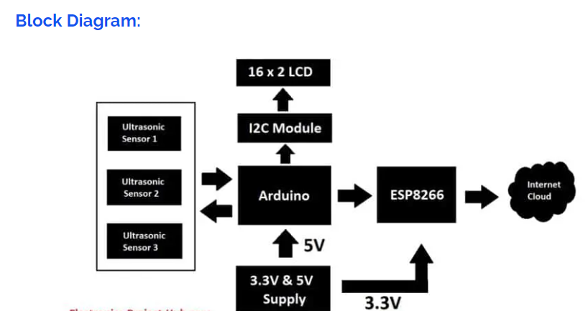

**Real-Time Data Display:**

* Implement a real-time data feed from IoT sensors to display parking space availability. Ensure that the data is updated frequently to reflect the current status.

**Search and Filter Options:**

* Include search and filter options to allow users to specify criteria such as location, price range, parking type (e.g., covered, open-air), and accessibility features (e.g., disabled parking).

Circuit diagram For park Monitoring system:

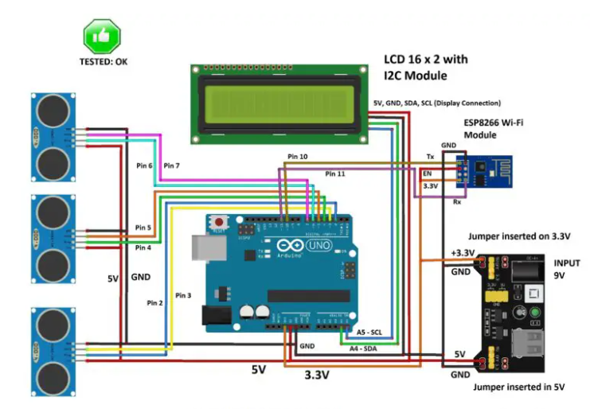

CAMERA BASED PARKING:

* Camera-based smart parking in the Internet of Things (IoT) is a technology solution that leverages cameras and IoT devices to efficiently manage and monitor parking spaces.(refer fig) It aims to improve the parking experience for both drivers and parking operators by providing real-time information about parking space availability and helping drivers find and reserve parking spots more easily.

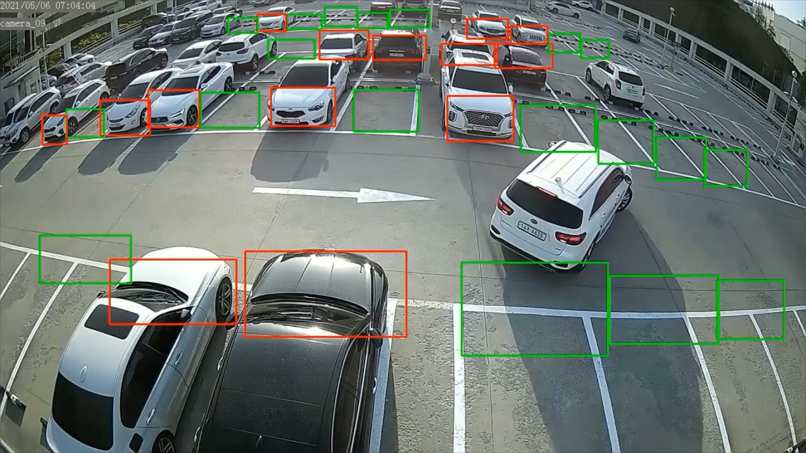

Fig: Camera based parking

Integration Approach:

**Sensor Connectivity:**

* Ensure that the IoT sensors are correctly installed and connected to the Raspberry Pi. Sensors may use various communication protocols, such as GPIO, UART, I2C, or SPI, depending on the sensor type.

**Raspberry Pi Configuration:**

Set up the Raspberry Pi with the necessary operating system and software libraries. Ensure that the Raspberry Pi has internet connectivity via Wi-Fi or Ethernet

Shopping mall parking place: 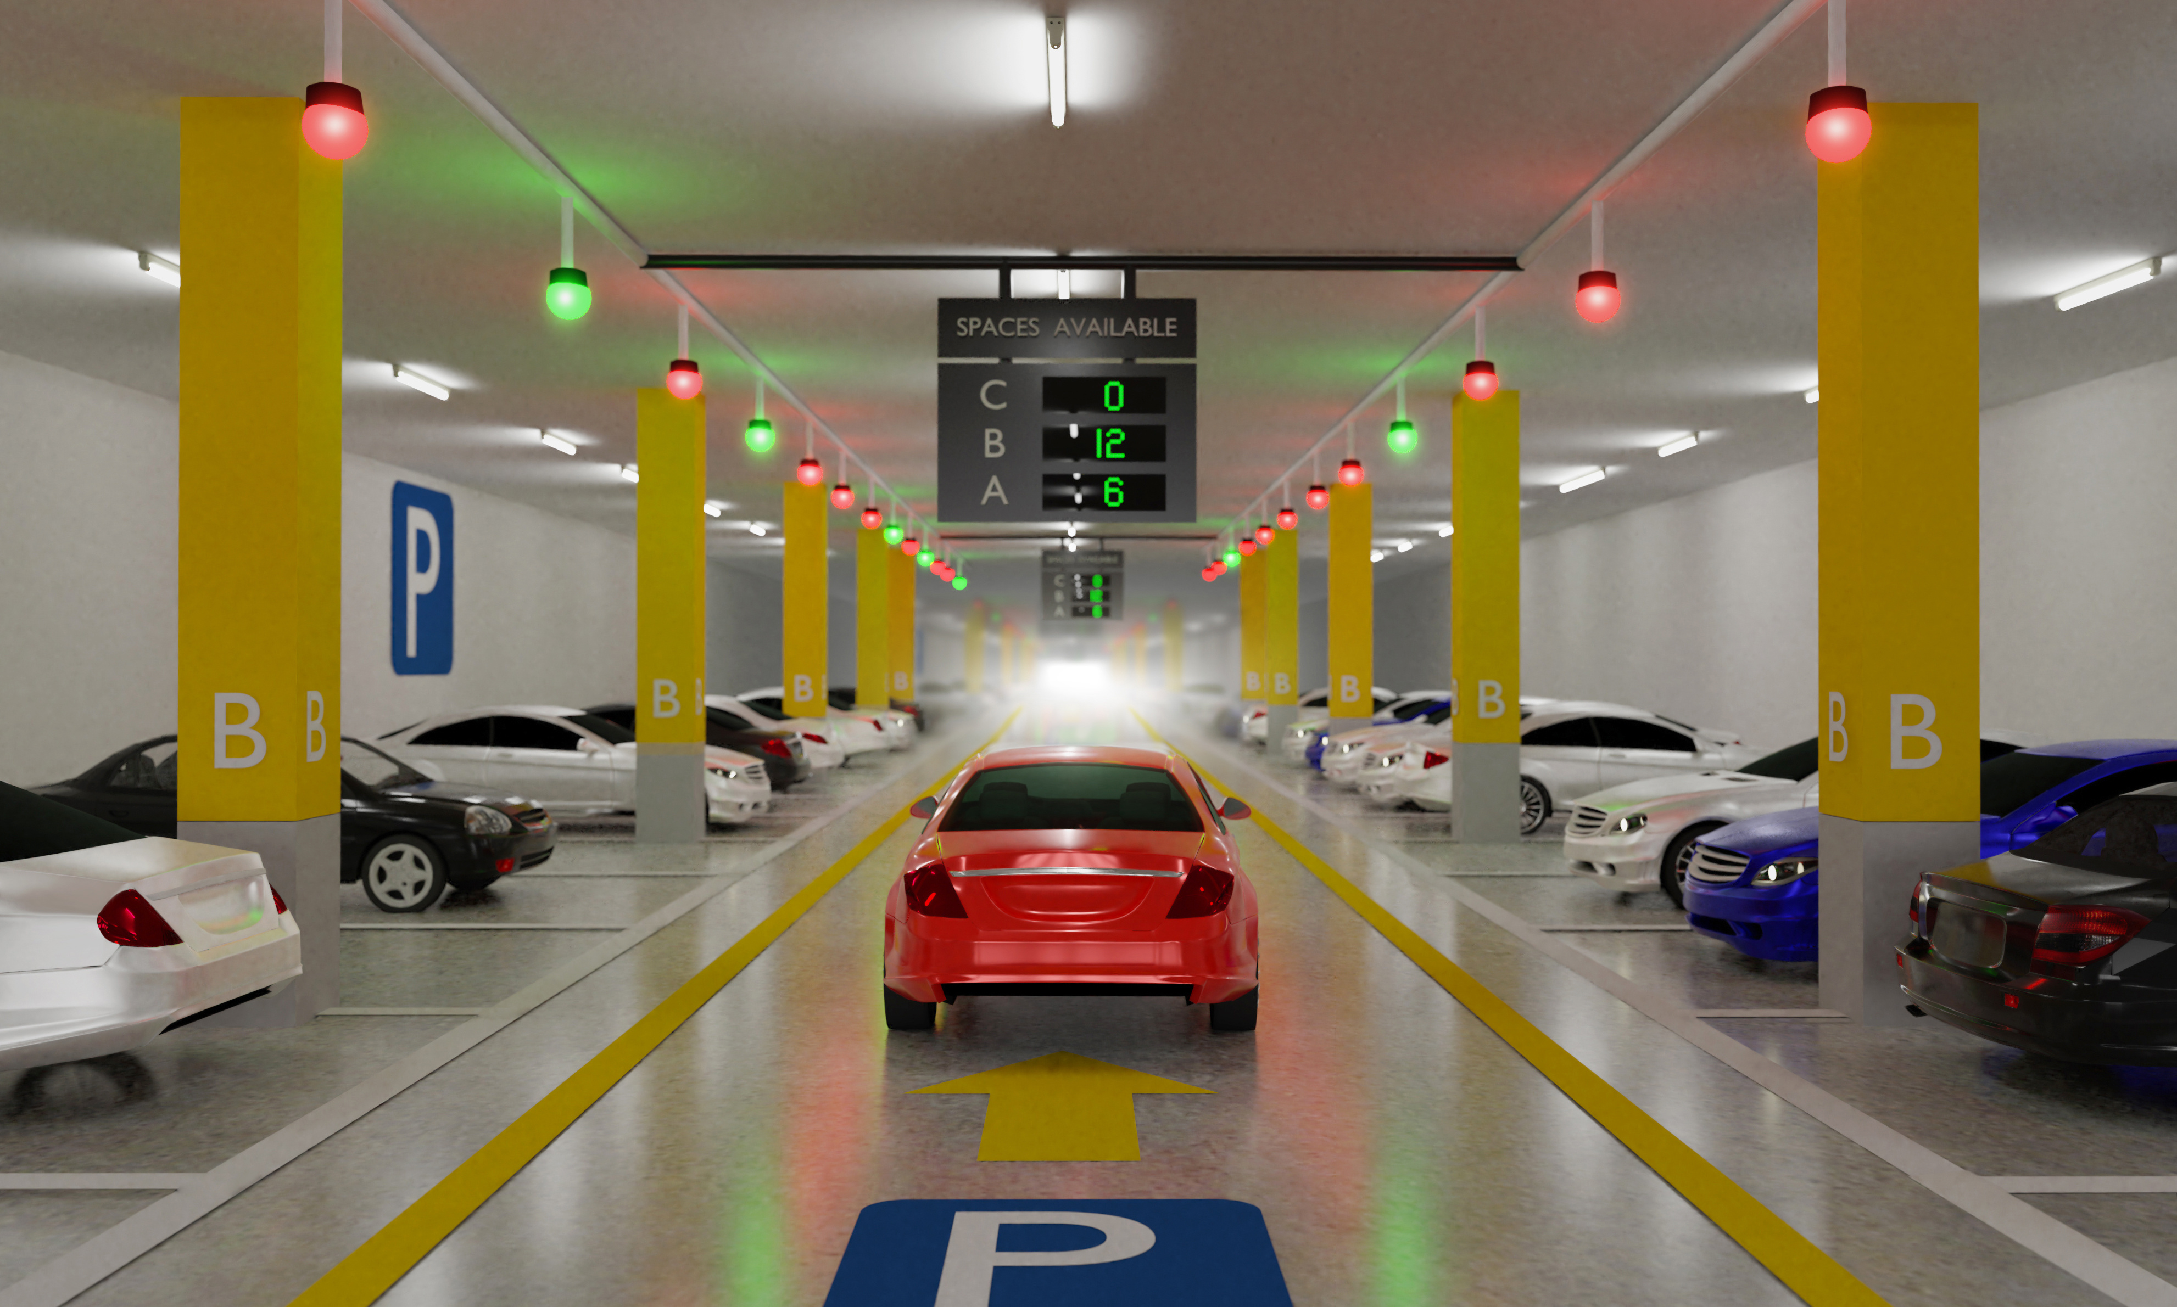

**Data Transmission:**

Establish a data transmission mechanism to send the processed sensor data to a central server or cloud platform. You can use protocols like HTTP, MQTT, or WebSocket for this purpose.

Datas are transmit in the shopping mall main server.

**Real-Time Updates to Mobile App:**

Ensure that the mobile app can periodically request and receive real-time parking availability updates from the server or cloud platform.

Mobile is developed using python.

Make app for parking .

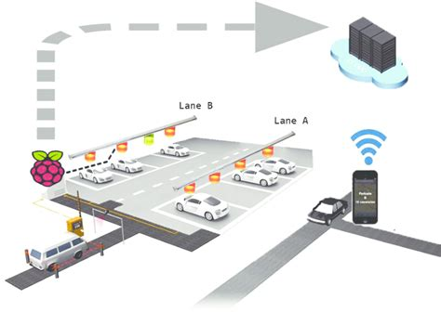

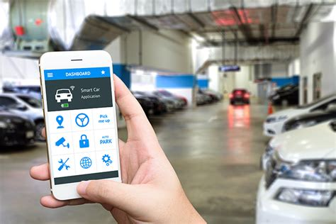

**Conclusion**

The development of the Internet of Things and cloud technology opens up new opportunities for smart cities. Smart parking has always been the backbone of building smart cities. IoT-based smart parking system offers real-time slots, parking procedures, information and improves users’ ability to save time on proper parking. It helps to solve growing traffic congestion concerns. As for future work, users can book parking in a remote location. GPS, reservations, and license plate scanners can be included in the future.

THANK YOU!